**ASSIGNMENT 19a - PRISMS**

Complete the following table to help you name the following prisms.

1) 2)

3) 4)

5) 6)

|  |  |  |  |  |
| --- | --- | --- | --- | --- |
| **Prism** | **Right or oblique** | **Shape of Base** | **Shape of lateral faces** | **Name** |
| 1 | Right | Rectangle | Rectangle | Rectangular Prism |
| 2 | Right | Triangle | Rectangle | Triangular Prism |
| 3 | Oblique | Trapezoid | Rectangle | Trapezoid Prism |
| 4 | Right | Octagon | Rectangle | Octagonal Prism |
| 5 | Right | Pentagon | Rectangle | Pentagonal Prism |
| 6 | Oblique | Parallelogram | Parallelogram | Parallelogram Prism |

**ASSIGNMENT 19b – NETS OF PRISMS**

1) Draw nets for each of the following prisms. Label the side lengths. Drawings do NOT need to be to scale.

a)

8 in

8 in

20 in

b)

25 cm

5 cm

2) The net for a right octagonal prism was drawn by two students as shown below. Which is the correct net? Explain your answer.

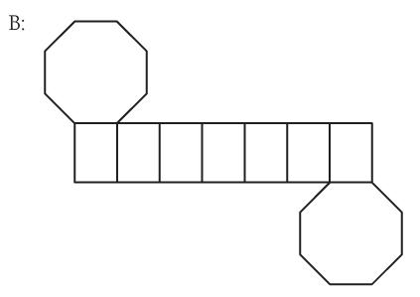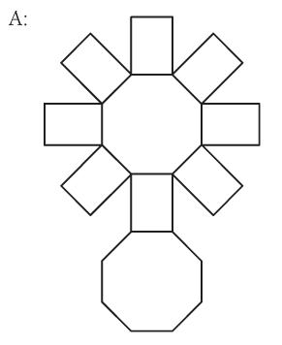

The second net is the correct net because when you open up the cylinder, there is one octagon on one side and there is all the lines in between and there is an octagon on the other side where is the first diagram, there is an octagon in the middle with lines around it.

**ASSIGNMENT 19c – SURFACE AREA OF PRISMS USING NETS**

For the following prisms, draw a net and calculate the surface area.

1)

Sketch on paper

Formula for Surface Area: 2lh + 2wh + 2lw

27 cm = 27 x 11 x 2 + 11 x 16 x 2 + 16 x 27 x 2

= 1810 cm^2

11 cm

16 cm

2) 10 in.

Sketch on paper

Formula for Surface Area: b x h + 2wh + lh

= 10 x 6 + 18 x 8 x 2 + 18 x 6

= 456 in.^2

18 in.

8 in.

6 in.

**ASSIGNMENT 19d – SURFACE AREA OF RECTANGULAR PRISMS**

1) Jim is making a toy box. The box is 24 in. long, 18 in. deep and 36 in. tall.

a) Label the toy box drawn below.

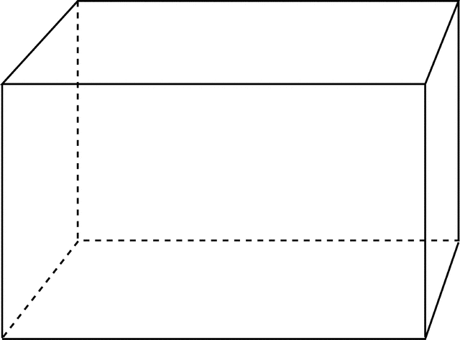

36 in. (h) 18 in. (d)

24 in.

b) Calculate the surface area of the toy box in square inches.

Formula for Surface Area: 2lw + 2wh + 2lh

= 2 x 36 x 18 + 18 x 24 x 2 + 2 x 24 x 36

= 3888 in. x 12 (square inches)

= 46,656 square inches

2) Vicki is tiling her shower stall. The dimensions of the shower stall are 35” by 35” by 8 feet tall. If Vicki only needs to tile 3 sides (the 4th side is the door!), what is the surface area she will be tiling? Hint: the 3 sides are all the same size. Calculate the area of one of these surfaces, and then multiply it by 3.

Formula for Surface Area: l x w x h

Convert 8 ft. into in. = 12 x 8 = 96 in.

= 35 x 96 x 3 = 10,080 inches

**ASSIGNMENT 19e – SURFACE AREA OF CYLINDERS AND SPHERES**

1) Draw a net of a tin can that has a radius of 15 cm and is 75 cm long. Then use the formula for surface area of a cylinder to calculate the surface area of the tin can.

Formula for Surface Area: 2 x 3.14 x r x h + 2 x 3.14 x r x r (r^2)

= 2 x 3.14 x 15 x 75 + 2 x 3.14 x 15 x 15

= 8478 cm^2

2) Calculate the surface area of a cylindrical pop can that is 37 cm tall and has a *diameter* of 8 cm.

Diameter: 8 cm/2 = Radius: 4 cm

Formula for Surface Area: 2 x 3.14 x r x h + 2 x 3.14 x r x r (r^2)

= 2 x 3.14 x 4 x 37 + 2 x 3.14 x 4 x 4

= 1029.92 cm^2

3) A sphere has a radius of 7.6 m. What is its surface area?

Formula for Surface Area: 4 x 3.14 x r x r

= 4 x 3.14 x 7.6 x 7.6

= 725.47 cm^2

4) Find the radius of a sphere with a surface area of 6700 m2. See page 28!

Formula for Surface Area: 6700/4/3.14

= 533.44 = Square Root of 533.44

= 23.1 m is the radius

5) A hemisphere is **half** a sphere. What is the surface area of a hemisphere with a radius of 28.4 mm? Do not include the circular face created by cutting the sphere.

Formula for Surface Area: 4 x 3.14 x r x r

= 4 x 3.14 x 28.4 x 28.4/2 (hemisphere)

= 10,130.39/2 = 5,065.2 mm^2

**ASSIGNMENT 19f – SURFACE AREA OF PYRAMIDS AND CONES**

1) Find the total surface area of the square-based pyramid shown below.

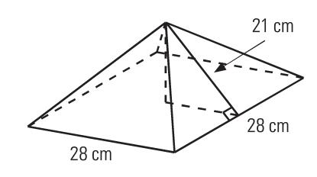

Formula of Surface Area: 2bs + b^2

= 28/2 = 14 x 14 = 21 x 21 = 441 – 196 = 246

Square Root of 246 = 15.68 cm

= 2 x 15.68 x 14 + 28 x 28

= 1223.04 cm^2

2) Calculate the surface area of the following pyramid given the measurements shown.

Formula of Surface Area: s^2 + b x h

Slant height = 13.25 m /2 x 4

= 16 x 16 = 256 m^2

= 16 x 13.25/2 x 4 = 424 m^2

16 m = 256 + 424 = 680 m^2

16 m

3) Calculate the slant height, and then the surface area of the pyramid below.

height, h = 12 cm

12 cm Formula for Surface Area: s^2 + b x h/2 x4

= 18 x 18 = 324 cm^2

18 cm = 18 x 12/2 x 4 = 432 cm^2

18 cm = 324 + 432 = 756 cm^2

Calculate the surface area of the cone shown below.

4)

25 cm Formula for Surface Area: 3.14 x r x s + 3.14 x r x r

= 3.14 x 25 x 67 + 3.14 x 25 x 25

= 7,222 cm^2

67cm

5)

Formula for Surface Area: d/2 = 3.14 x r x s + 3.14 x r^2

= 88/2 = 44 x 3.14 x 78 + 3.14 x 44 x 44

78 mm = 16,855.52 mm^2

88 mm

6) 22.5 m

Formula for Surface Area: 3.14 x r x s + 3.14 x r^2

= 22.5/2 = 11.25 x 11.25 + 18 x 18 = 450.56 m

Square Root of 450.56 = 21.23 m

= 3.14 x 11.25 x 21.23 + 3.14 x 11.25 x 11.25

18 m = 1,147.36 m^2